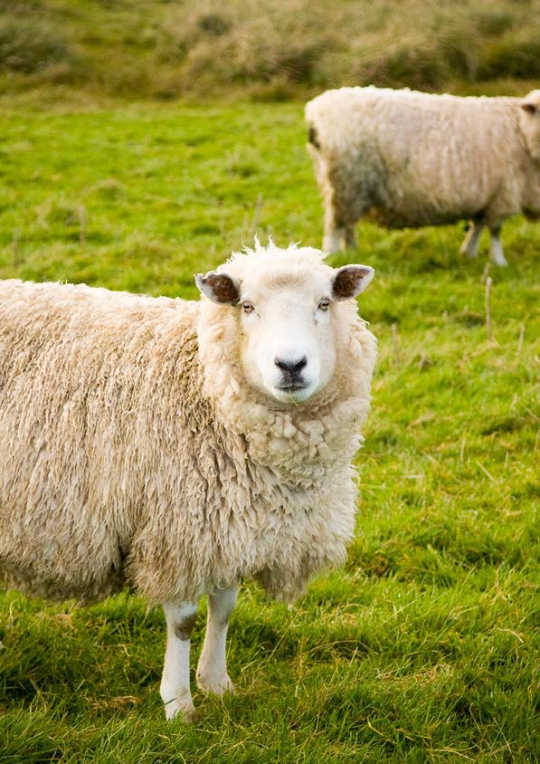

Farm Environment Plan Workbook
GISBORNE DISTRICT COUNCIL

BUSINESS DETAILS

Farm name
Address
Legal description and farm identifier | This information is available through the GDC website
Owner(s)
Phone
Mobile
Email
Manager
Phone
Mobile
Email
Who is primarily responsible for the implementation of this Farm Environment Plan? | Both Lessee and lessor are responsible and it is recommended for all parties involved to sign this document
CONTACT DETAILS (IF DIFFERENT FROM ABOVE)
Phone
Mobile
Email
Resource consents held in relation to this business (list consent numbers)

ONE: FARM PLAN DETAILS (ATTACH/INCLUDE FARM PLAN HERE)

DESCRIBE THE FARM ENTERPRISE AND THE SIZE OF THE OPERATION (HECTARES)
OUTLINE THE GOALS AND OBJECTIVES FOR THE BUSINESS (OPTIONAL)

DESCRIBE THE EXISTING FARM MANAGEMENT POLICY IF APPLICABLE, INCLUDING:
Fertiliser Input
Annual and permanent crops grown
Stock types and classes
Numbers wintered
Winter management
Feed supplement inputs
Other

TWO: NUTRIENT MANAGEMENT

NUTRIENT BUDGET
SPRAY PLAN

THREE: LAND MANAGEMENT UNIT CHART

LMU | DESCRIPTION
STRENGTHS | WEAKNESSES AND RISKS | USES AND MANAGEMENT

LMU | DESCRIPTION
STRENGTHS | WEAKNESSES AND RISKS | USES AND MANAGEMENT

LMU | DESCRIPTION
STRENGTHS | WEAKNESSES AND RISKS | USES AND MANAGEMENT

LMU | DESCRIPTION
STRENGTHS | WEAKNESSES AND RISKS | USES AND MANAGEMENT

LMU | DESCRIPTION
STRENGTHS | WEAKNESSES AND RISKS | USES AND MANAGEMENT

LMU | DESCRIPTION
STRENGTHS | WEAKNESSES AND RISKS | USES AND MANAGEMENT

LMU | DESCRIPTION
STRENGTHS | WEAKNESSES AND RISKS | USES AND MANAGEMENT

LMU | DESCRIPTION
STRENGTHS | WEAKNESSES AND RISKS | USES AND MANAGEMENT

LMU | DESCRIPTION
STRENGTHS | WEAKNESSES AND RISKS | USES AND MANAGEMENT

LMU | DESCRIPTION
STRENGTHS | WEAKNESSES AND RISKS | USES AND MANAGEMENT

LMU | DESCRIPTION
STRENGTHS | WEAKNESSES AND RISKS | USES AND MANAGEMENT

LMU | DESCRIPTION
STRENGTHS | WEAKNESSES AND RISKS | USES AND MANAGEMENT

OBJECTIVE 1 – NUTRIENT MANAGEMENT
What practices help you achieve objective one?  e.g. All fertiliser applied in lower risk months | How can you demonstrate this?  e.g. Provide records of fertiliser application including dates, rates, soil  temperature and rainfall
OBJECTIVE 2 – SOIL MANAGEMENT
What practices help you achieve objective two? | How can you demonstrate this?

OBJECTIVE 4 – LIVESTOCK MANAGEMENT
OBJECTIVE 3 – WETLANDS AND RIPARIAN MANAGEMENT
What practices help you achieve objective three? | How can you demonstrate this?
OBJECTIVE 4 – LIVESTOCK MANAGEMENT
What practices help you achieve objective four? | How can you demonstrate this?

OBJECTIVE 5 – IRRIGATION MANAGEMENT
What practices help you achieve objective five? | How can you demonstrate this?
OBJECTIVE 6 – OFFAL PITS
What practices help you achieve objective six? | How can you demonstrate this?

OBJECTIVE 7 – CROPPING MANAGEMENT
What practices help you achieve objective seven? | How can you demonstrate this?
OBJECTIVE 8 – FIELD DRAINS
What practices help you achieve objective eight? | How can you demonstrate this?

OBJECTIVE 9 – COLLECTED ANIMAL EFFLUENT MANAGEMENT
What practices help you achieve objective nine? | How can you demonstrate this?
OBJECTIVE 10
What practices help you achieve objective ten? | How can you demonstrate this?

OBJECTIVE 1: NUTRIENT MANAGEMENT ISSUE/RISK |  | SIGNIFICANCE  (Low, Med, High)
RESPONSE | TIMEFRAME | RESPONSIBILITY

OBJECTIVE 2: SOIL MANAGEMENT ISSUE/RISK |  | SIGNIFICANCE  (Low, Med, High)
RESPONSE | TIMEFRAME | RESPONSIBILITY

OBJECTIVE 3: WETLANDS & REPARIAN MANAGEMENT ISSUE/RISK |  | SIGNIFICANCE  (Low, Med, High)
RESPONSE | TIMEFRAME | RESPONSIBILITY

OBJECTIVE 4: LIVESTOCK MANAGEMENT ISSUE/RISK |  | SIGNIFICANCE  (Low, Med, High)
RESPONSE | TIMEFRAME | RESPONSIBILITY

OBJECTIVE 5: IRRIGATION MANAGEMENT ISSUE/RISK |  | SIGNIFICANCE  (Low, Med, High)
RESPONSE | TIMEFRAME | RESPONSIBILITY

OBJECTIVE 6: OFFAL PITS ISSUE/RISK |  | SIGNIFICANCE  (Low, Med, High)
RESPONSE | TIMEFRAME | RESPONSIBILITY

OBJECTIVE 7: CROPPING MANAGEMENT ISSUE/RISK |  | SIGNIFICANCE  (Low, Med, High)
RESPONSE | TIMEFRAME | RESPONSIBILITY

OBJECTIVE 8: FIELD DRAINS ISSUE/RISK |  | SIGNIFICANCE  (Low, Med, High)
RESPONSE | TIMEFRAME | RESPONSIBILITY

OBJECTIVE 9: COLLECTED ANIMAL EFFLUENT ISSUE/RISK |  | SIGNIFICANCE  (Low, Med, High)
RESPONSE | TIMEFRAME | RESPONSIBILITY

OBJECTIVE 10: ISSUE/RISK |  | SIGNIFICANCE  (Low, Med, High)
RESPONSE | TIMEFRAME | RESPONSIBILITY

SIX: IMPLEMENT, MONITOR & REVIEW

Have you completed the following?
Create a farm map that shows sites of interest for farm environmental planning
Identified areas of land that can be farmed or managed in a similar way because of underlying physical similarities. Complete the resource chart, evaluating the strengths and weaknesses of each LMU.
Reviewed and updated your current nutrient budget using LMUs. Reviewed and updated your current spray management plan.
Identified environmental objectives and listed good management practices to achieve each one. Recorded other things you do that demonstrate good environment management practices.
Completed your Farm Environment Plan and signed the implementation agreement at the bottom of this page.

CONGRATULATIONS ON DESIGNING A FARM
ENVIRONMENT PLAN SPECIFICALLY FOR YOUR FARM
For full integration with farm business planning you may wish to refer to this FEP when making decisions about farm development and financial planning.
Once your plan is complete, the following should be signed, as appropriate.

RESPONSIBILITY FOR IMPLEMENTING THIS FARM PLAN
As the person responsible for implementing this plan, I confirm that the information provided is correct:
Name:
(plan implementer)
Position:

Signature: Date:

OWNER AND LESSEE COMMITMENT
As owner(s) of this farming business I/we are committed to ensuring that all activities on our property are undertaken in and environmentally sustainable and culturally sensitive manner. We agree to monitor our performance in meeting the management objectives and outcomes in this Plan, and take appropriate actions to address any areas where improvement is needed.
Name:
(owner/representative/delegated authority for a trust)

Signature: Date:
Name:
(lessee or lessee representative):

Signature: Date:

WORKSHOP FACILITATOR
I acknowledge that this FEP has been completed to a reasonable standards, and
has gained understanding of the FEP process.
Name:
(workshop facilitator)

Signature: Date:

